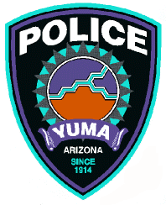
City of Yuma Police Department
Citizen Commendation/Recognition form

We value your opinion and want to recognize those employees who make an extra effort or do something extraordinary for our citizens. If you would like to commend a Police employee for their actions, you can do so by using this form. Thank you for taking the time to share this information regarding your experience with the Department.

- This form can be faxed to (928) 373-8864, hand delivered, or mailed to the Yuma Police Department Professional Standards Unit at 1500 S. 1st Avenue Yuma, AZ 85365.
- Or email/call: Professional Standards Unit
Sergeant James Frazier
1500 S. 1st Avenue
Yuma, AZ 85365
Phone: (928) 373-4674
Fax: (928) 329-7962
Email: James.frazier@YumaAZ.Gov

Information about you (or remain anonymous):

First Name: Last Name:

Home Phone: Cell Phone:

Email:________________________

Address: City, State, Zip Code:

Incident Information:

Incident/Report #: Date & Time of Incident:

Location of Incident:

Police Department Officer (s) or employee (s) involved:

Name Badge/ID#

Name Badge/ID#

Name Badge/ID#

Name Badge/ID#

Information about witnesses and/or individuals involved:

Name: Phone #:

Address: City, State, Zip Code:

Name: Phone #:

Address: City, State, Zip Code:

Name: Phone #:

Address: City, State, Zip Code:

Please tell us about the incident (attach additional pages if necessary):

(attach additional pages as needed).

